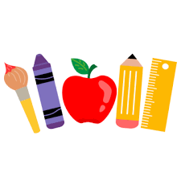

Welcome to

Mrs. Galligan’s Class

Dear Parents and Families…

I look forward to a wonderful year filled with fun and learning! Below is a list of supplies your child should bring to school the first day.

* 1 box sharpened pencils
* 1 box of Crayola markers
* 1 box of 24 Crayola crayons
* 1 box of Crayola colored pencils
* 1 pair of scissors
* 4 glue sticks
* 1 pencil box
* 1 change of clothes (including underwear or pull ups & wipes) in a plastic bag marked with your child’s name.

I hope you have a wonderful summer and I cannot wait to see you soon 😊

Mrs. Galligan